PROJECT DEVELOPMENT PHASE
UNESCO Heritage Treasures – Business Questions with Visualizations
1. Top 10 Countries by Heritage Area
This visualization represents the top 10 countries based on the total area covered by UNESCO World Heritage Sites. It helps identify countries with the largest heritage-protected land area. Countries with vast natural reserves and large cultural landscapes appear prominently, indicating strong conservation efforts and rich heritage value.
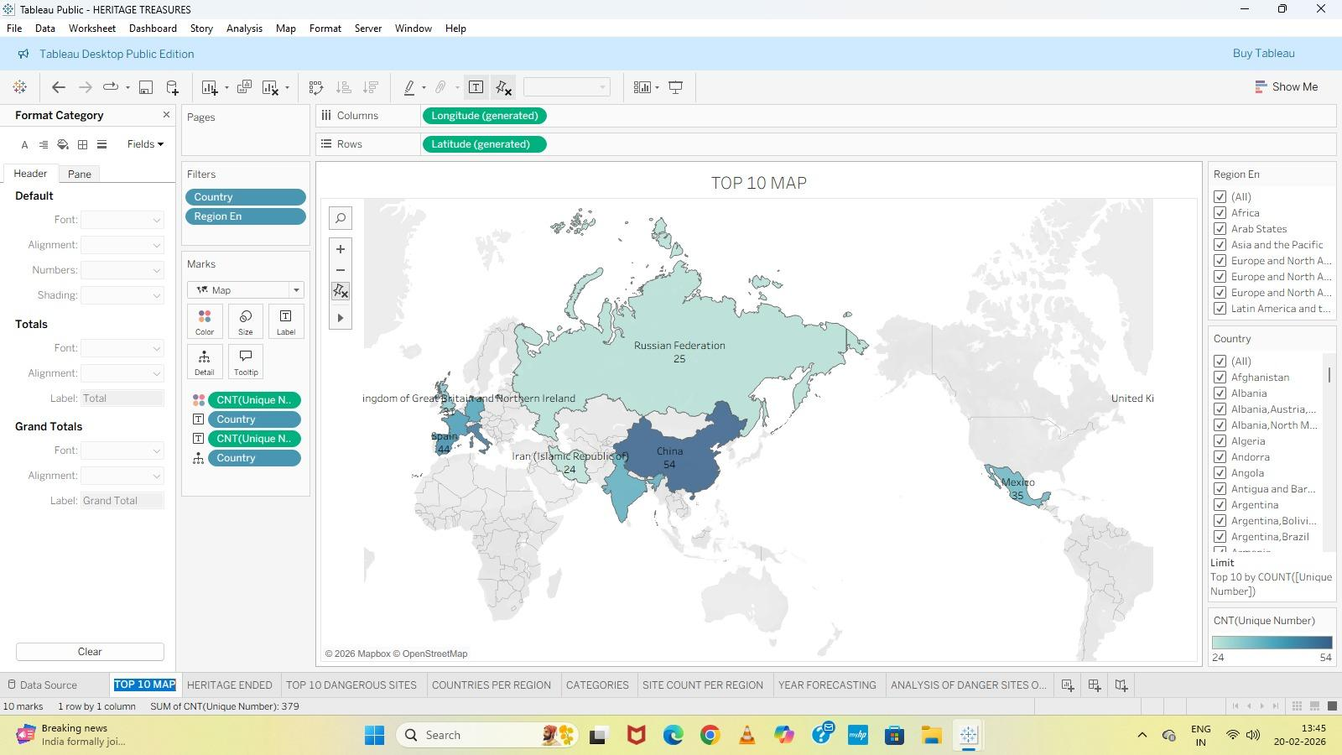
2. Top 10 Danger Sites
This visualization shows the top 10 UNESCO World Heritage Sites that are categorized as danger sites. These sites are under threat due to environmental, political, or human-made factors. The visualization helps in identifying critical heritage locations that require immediate protection and restoration measures.
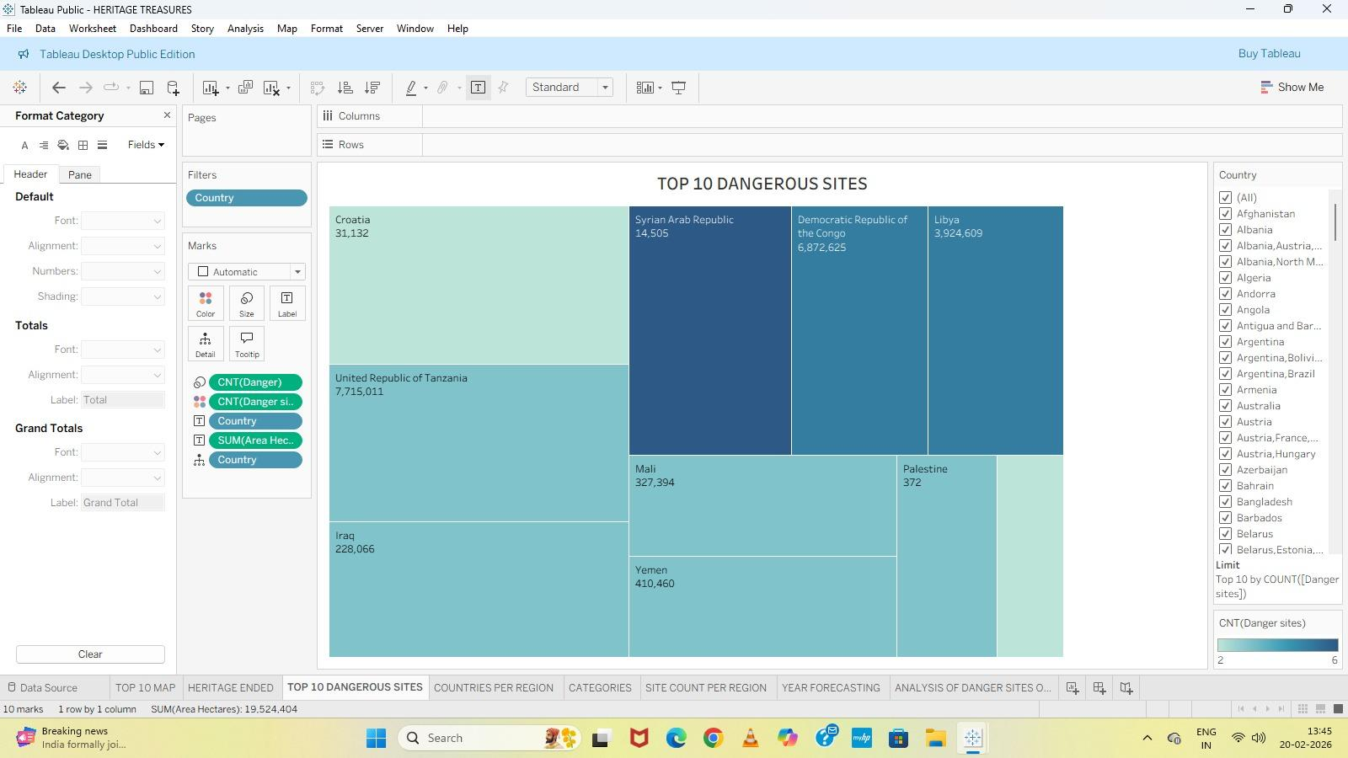
3. Countries Per Region
This visualization shows the distribution of countries across different UNESCO regions. It highlights how many countries from each region have at least one World Heritage Site. The visualization clearly indicates that Europe and North America have the highest number of participating countries, followed by Asia and the Pacific, Africa, Latin America and the Caribbean, and Arab States. This helps in understanding regional participation and global representation in UNESCO World Heritage listings.
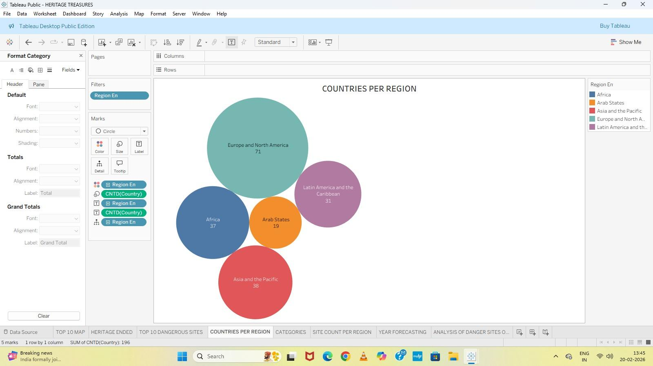
4 .Site Count per Region
This visualization highlights the number of endangered UNESCO World Heritage Sites across different regions. It provides insight into which regions face higher risks due to natural disasters, climate change, urbanization, or conflicts. The visualization emphasizes the need for focused conservation efforts in regions with a higher count of endangered sites
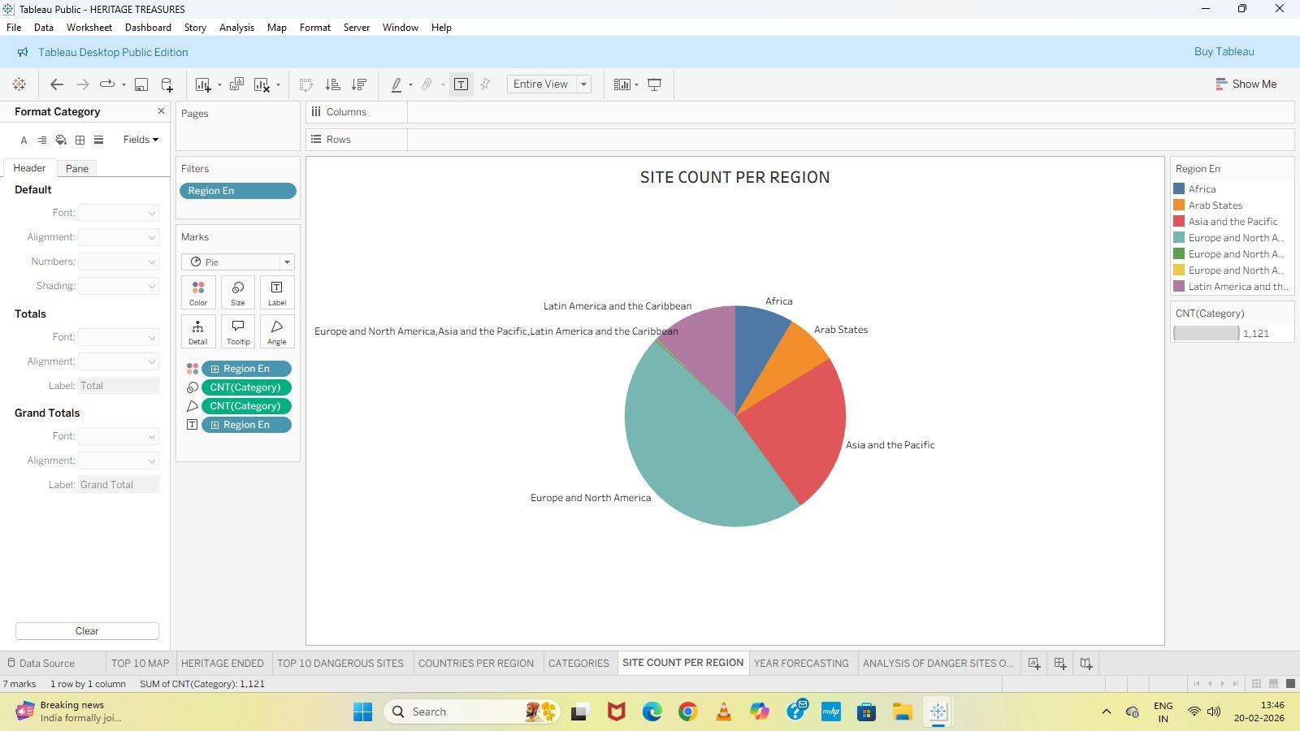
5.UNESCO World Heritage Explorer Dashboard
This dashboard combines multiple visualizations into a single interactive view. It provides a comprehensive overview of UNESCO World Heritage Sites by region, category, site count, endangered status, and area distribution. The dashboard allows users to explore global heritage patterns efficiently and supports data-driven insights for heritage conservation and analysis
